Prompt
I have used the final prompt:

Summary
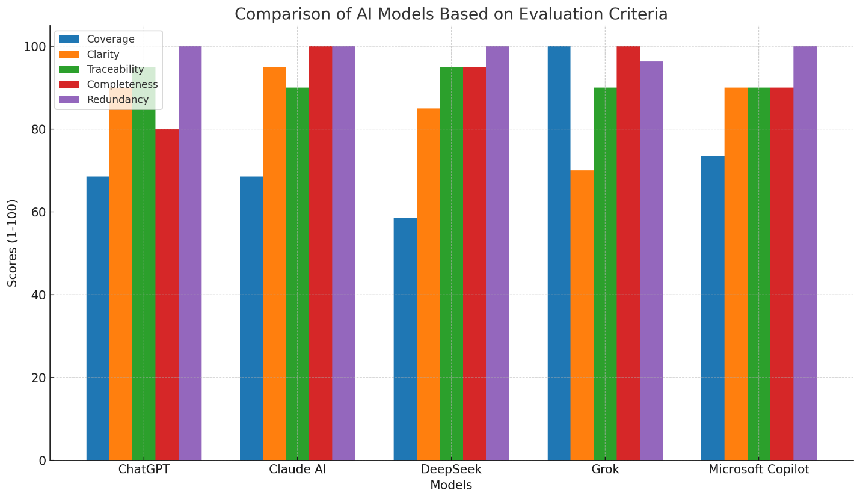
Overall, Grok performed the best in terms of sheer coverage and completeness, extracting all 159 requirements from the SRS, including the miscellaneous ones that the other models missed. However, it had the lowest clarity and some redundancy.
For a balance of high clarity, completeness, and traceability, Claude AI is the top performer. While it missed the miscellaneous requirements, it provided the most detailed and well-structured output for the requirements it did extract.
Microsoft Copilot is a strong all-around performer, with good scores in all categories and the second-best coverage.
Ultimately, the best model depends on your specific needs. If you require a tool that extracts every possible requirement from a document, regardless of clarity, Grok is the most suitable. If you prioritize a well-structured and highly detailed output for the core functional and non-functional requirements, Claude AI is the best choice.

